Software Change Notice

Purpose
To fix the problem of “RF horizontal noise” in Indonesia.

New File Version
V007_2
Changing Item and Mechanism
The following pictures, Fig1 & Fig2 & Fig3, show the changing points for this issue.
Fig1: Left side is new file/Right Side is old file
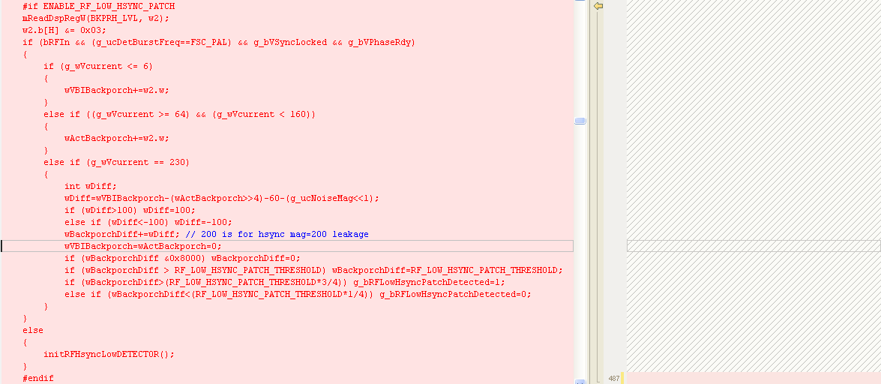
Fig2: Left side is new file/Right Side is old file
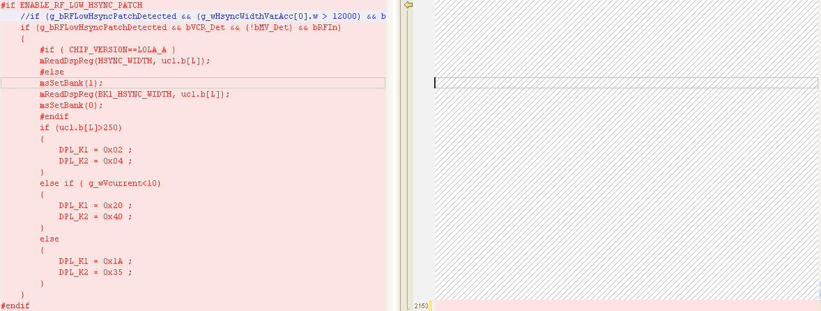

Fig3: Left side is new file/Right Side is old file
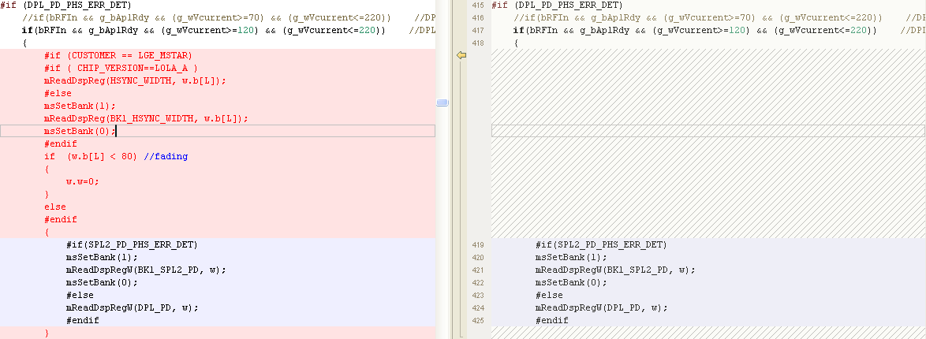

Explanation of Change
The new backporch level detection method is showed in Figure 1, it will accumulate the backporch level difference between VBI region and active region. When the difference is over threshold, and VCR signal is detected, the hsync PLL tracking speed will be adjusted (Figure 2). In Figure 3, the DPL phase error is cleared when hsync width is much smaller than non-standard to prevent DPL phase error calculation incorrect for fading signal.

Evaluation Result of New Code
The new backporch level detection method is tested in Indonesia factory, this kind of signal is detected only in 711.25Mhz channel. After updating new dsp code, the video quality of 711.25Mhz channel is the same as compare set, the horizontal noise is improved.

Owner : BY.Tsai
Reviewed by Book.Weng
Contact Window : BY.Tsai

Customer Approval

(Customer Name) agree to accept (File Version) as the official version as of (Date)

_______________________ (Name)
(Title)
(Company)

